BMS INSTITUTE OF TECHNOLOGY & MANAGEMENT

BANGALORE-560019



**Students Mini Project Assessment and Review Committee**

**Mini Project: Review 2**

|  |  |  |  |  |
| --- | --- | --- | --- | --- |
| Batch No: 16 | | **Guide Name:**  **Dr. MANOJ H M** | | **Submission Date:** |
| **Mini Project Title:**  **IoT and ML-Driven Water Forensics for Illegal Dumping Detection** | | | | |
| **Sl No** | **USN** | | **Name** | |
| **1** | **1BY22AI098** | | **SIRI MANJUNATH** | |
| **2** | **1BY22AI099** | | **SMRITI** | |
| **3** | **1BY22AI100** | | **SONALI KUMARI** | |
| **4** | **1BY22AI110** | | **TISHA SAKLECHA** | |
| **Mini Project Category** | | | **Research, Environmental and Societal** | |

**Signature of Guide Signature of SPARC HOD**

BMS INSTITUTE OF TECHNOLOGY & MANAGEMENT

****Yelahanka, Bangalore – 560 019

Department of Artificial Intelligence and Machine Learning

Mini Project work

**“IoT and ML-Driven Water Forensics for Illegal Dumping Detection”**

Submitted By:

1. SIRI MANJUNATH [1BY22AI098]

2. SMRITI [1BY22AI099]

3. SONALI KUMARI [1BY22AI099]

4. TISHA SAKLECHA [1BY22AI110]

Under the Guidance of

Dr. MANOJ H M

Associate Professor

Dept. of AIML

BMSIT&M

2024-2025

**Semester: V**

**BAI506- Mini Project Work Review I & II**

**Mini Project Work Review I & II Course Outcome**

**CO1:** Design and construct a solution for an identified real-life problem with societal importance using software engineering approach ethically.

**CO2**: Make use of programming skills to manage as an individual or in a team, in development of technical projects using appropriate tools.

**CO3**: Develop effective presentation and communication skills in presenting project related activities.

**CO4**: Build quality document of project work for publications, patenting, and final thesis.

**CO-PO-PSO MAPPING**

|  |  |  |  |  |  |  |  |  |  |  |  |  |  |
| --- | --- | --- | --- | --- | --- | --- | --- | --- | --- | --- | --- | --- | --- |
| **CO No.** | **PO1** | **PO2** | **PO3** | **PO4** | **PO5** | **PO6** | **PO7** | **PO8** | **PO9** | **PO10** | **PO11** | **PSO1** | **PSO2** |
| CO1 | 3 | 3 | 3 | 3 | - | - | 3 | - | 1 | - | - | 3 | 3 |
| CO2 | 1 | 2 | 1 | - | 3 |  | 2 | 2 | 3 | 3 | - | 3 | - |
| CO3 | - | - | - | - | - | 1 | 2 | 2 | 3 | - | 2 | 3 | 1 |
| CO4 | 3 | 3 | 3 | 2 | 3 | 1 | 1 | - | 3 | 3 | 2 | 3 | 2 |
| **Average** | 1.75 | 2 | 1.75 | 1.25 | 1.5 | 0.5 | 2 | 1 | 2.5 | 1.5 | 1 | 3 | 1.5 |

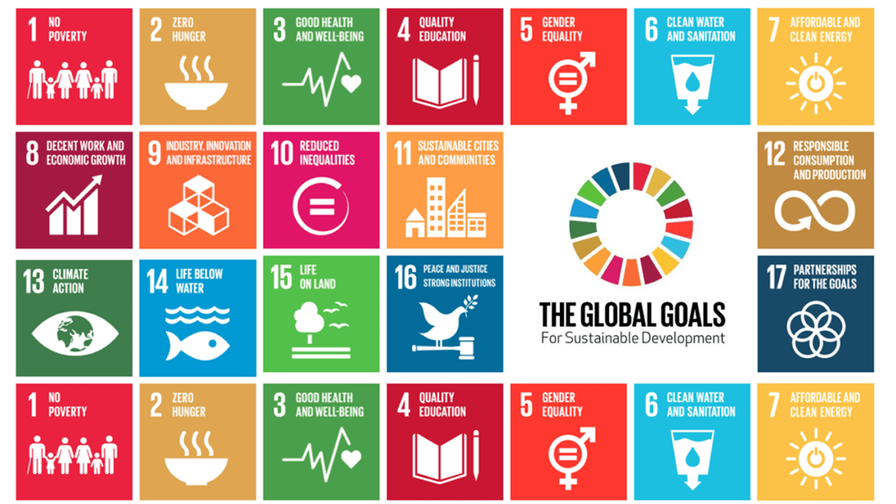**SDG (Sustainable Development Goals) Mapping**

**The relevant SDG (Sustainable Development Goals) are:**

**SDG 3: Good Health and Well-Being**

* **Justification**: By preventing hazardous chemical dumping and water contamination, the project protects human health. Contaminated water can lead to severe diseases, including those caused by heavy metals, toxic chemicals, and pathogens.
* **Impact**: Ensures access to safer water supplies, reducing the burden of waterborne diseases and improving overall community well-being.

**SDG 6: Clean Water and Sanitation**

* **Justification**: Focuses on monitoring and maintaining water quality to prevent pollution.
* **Impact**: Promotes access to clean and safe water for sustainable human and ecosystem health.

**SDG 9: Industry, Innovation, and Infrastructure**

* **Justification**: Utilizes advanced IoT and machine learning technologies for real-time water monitoring and anomaly detection.
* **Impact**: Encourages sustainable industrial practices and innovation in environmental monitoring systems.

**SDG 11: Sustainable Cities and Communities**

* **Justification**: Contributes to building sustainable and environmentally responsible urban systems by addressing illegal dumping in water sources.
* **Impact**: Improves the livability and resilience of communities.

**SDG 13: Climate Action**

* **Justification**: Reduces pollution in water bodies, which is crucial for mitigating the effects of climate change on ecosystems and communities.
* **Impact**: Supports proactive climate-related water resource management.

**SDG 14: Life Below Water**

* **Justification**: Protects aquatic ecosystems by detecting and preventing harmful pollutants in water.
* **Impact**: Enhances marine biodiversity and the health of water bodies.

**SDG 15: Life on Land**

* **Justification**: Prevents contaminants in water from impacting terrestrial ecosystems and agricultural lands.
* **Impact**: Supports biodiversity conservation and sustainable land management.

*Content of Report*

**Abstract of Mini Project:** (1 paragraph not more than 300 words) **–Brief description of Mini Project.**

**Methodology: Theoretical Analysis / Experimental Observations / Novel Algorithms / Tools / Techniques.**

**Implementation**

**Programming language and the algorithms used for implementation.**

**The implementation of each module of the project – diagram and description.**

**System Testing**

**Test Environment Description (Assumptions, if any should be specified)**

**All Possible Test cases – The implemented project should be tested against all possible inputs and should be checked for the expected outcomes.**

**Results and Discussions**

**Detailed Output of the implemented Mini project- Screen shots and description.**

**Conclusion : Self introspection of the project.**

**References: (IEEE format) – what you referred?**

*Note: The gray coloured text is the hint of what information is expected in that section*

**Common guidelines for preparing the report**

* Each page should have header and footer
  + Header – Project Name (LHS)
  + Footer - Dept Name and BMSIT&M (LHS), Year of submission (CENTER), Page No (RHS)
* Use Times New Roman Font type
* All the main headings should be 16’’ Bold
* All the sub headings should be 14’’ Bold
* All running text should be 12’’ Justified and 1.5 line spacing
* Do not underline
* All the abbreviations has to be expanded when they are used for the first time and can be abbreviated in further use
* Use the common cover(first) page **– see next page**

Note: In prior guides signature is required in this report SPARC committee members will sign on the day of presentation